SPRING AND HIBERNATE FOR BEGINNERS

SECTION 21: HIBERNATE CRUD FEATURES

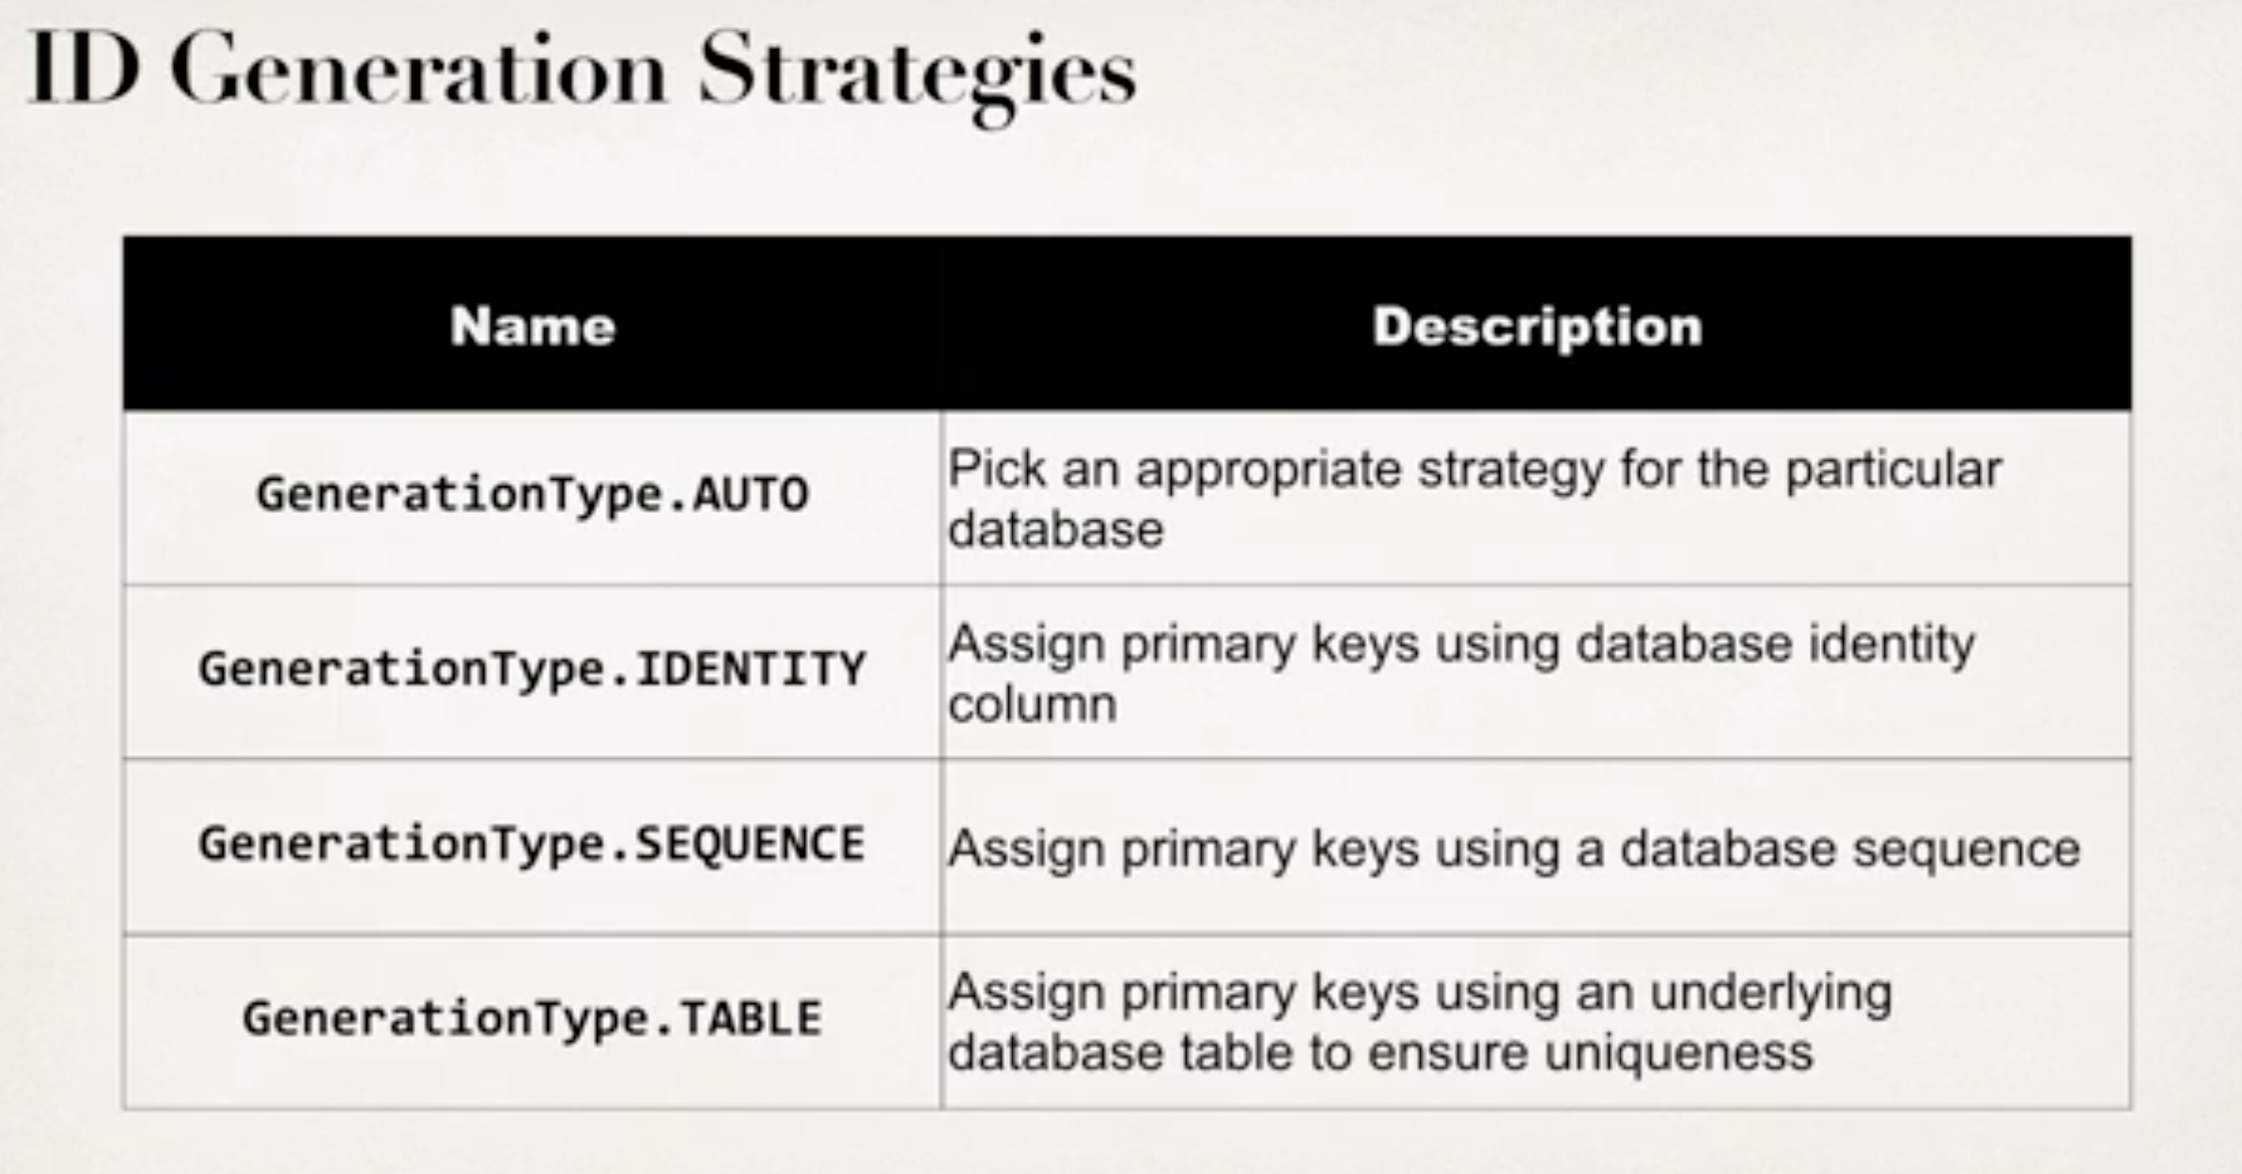

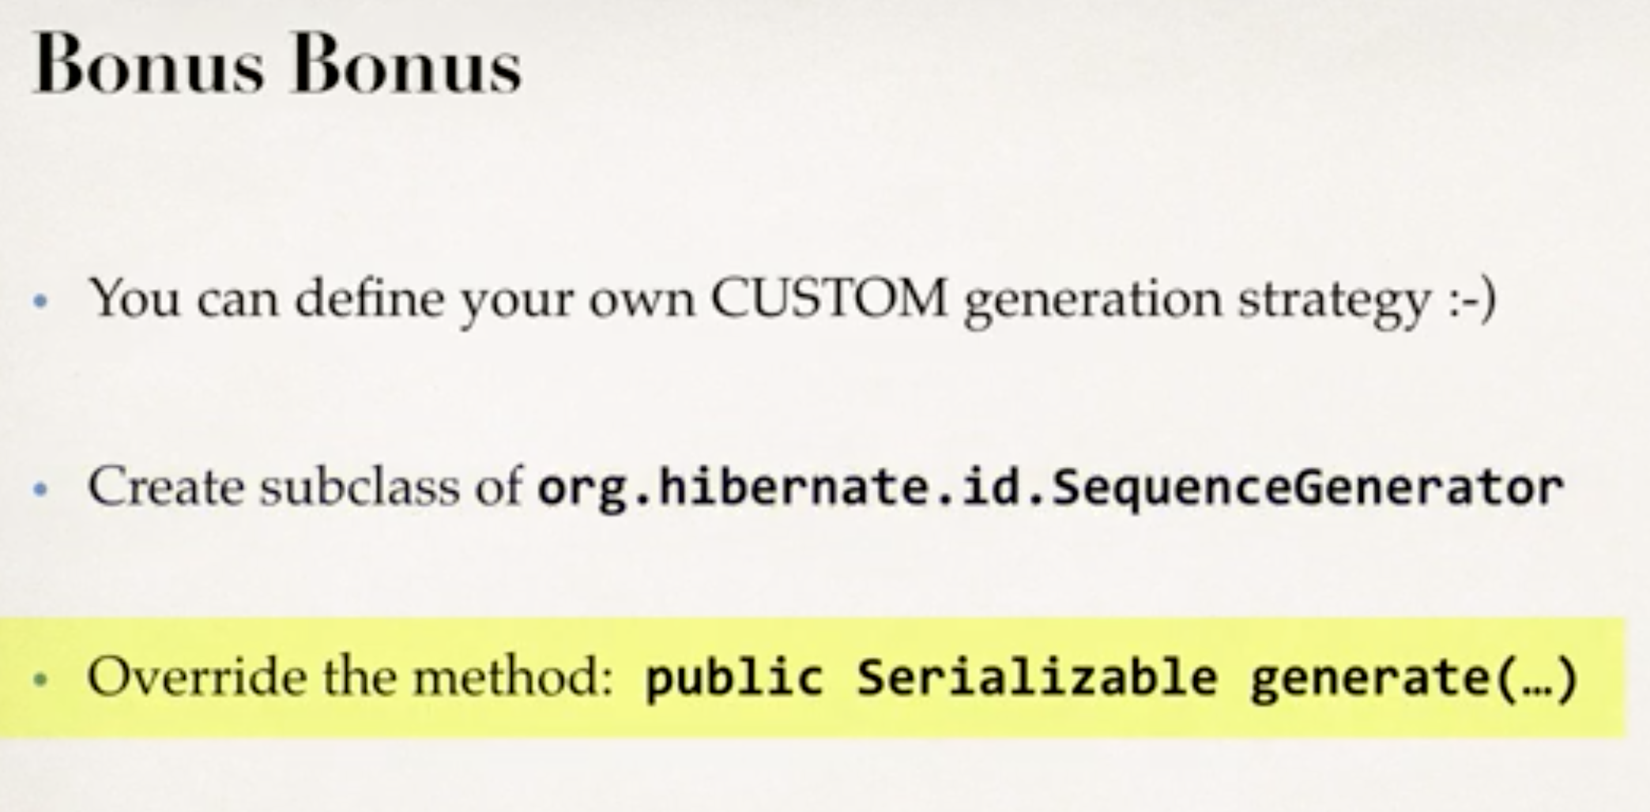

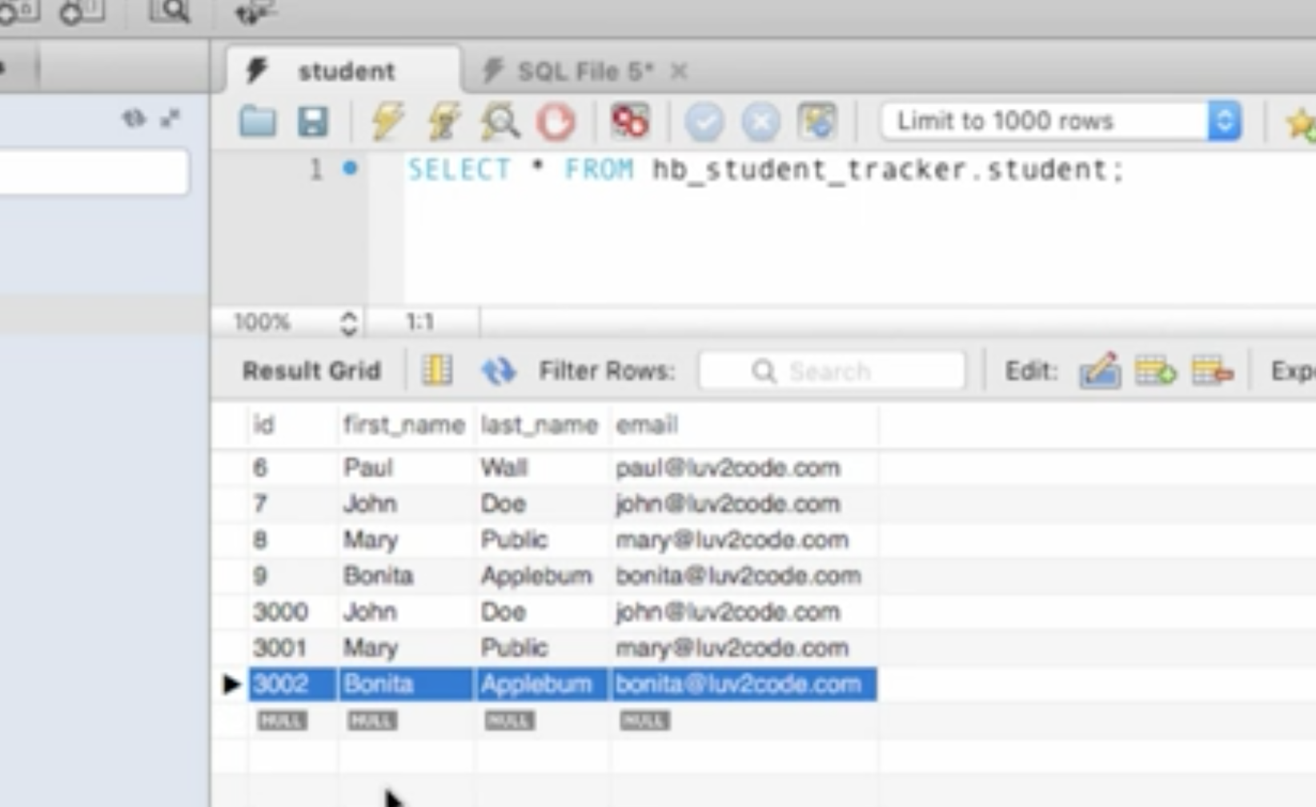

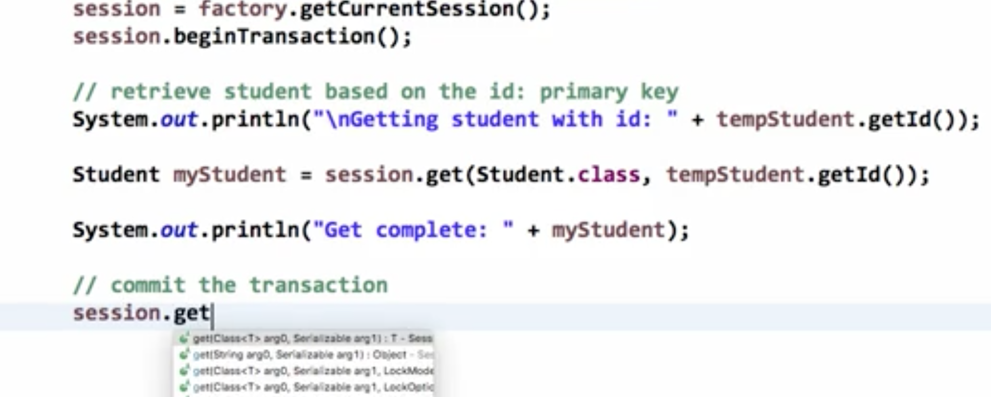

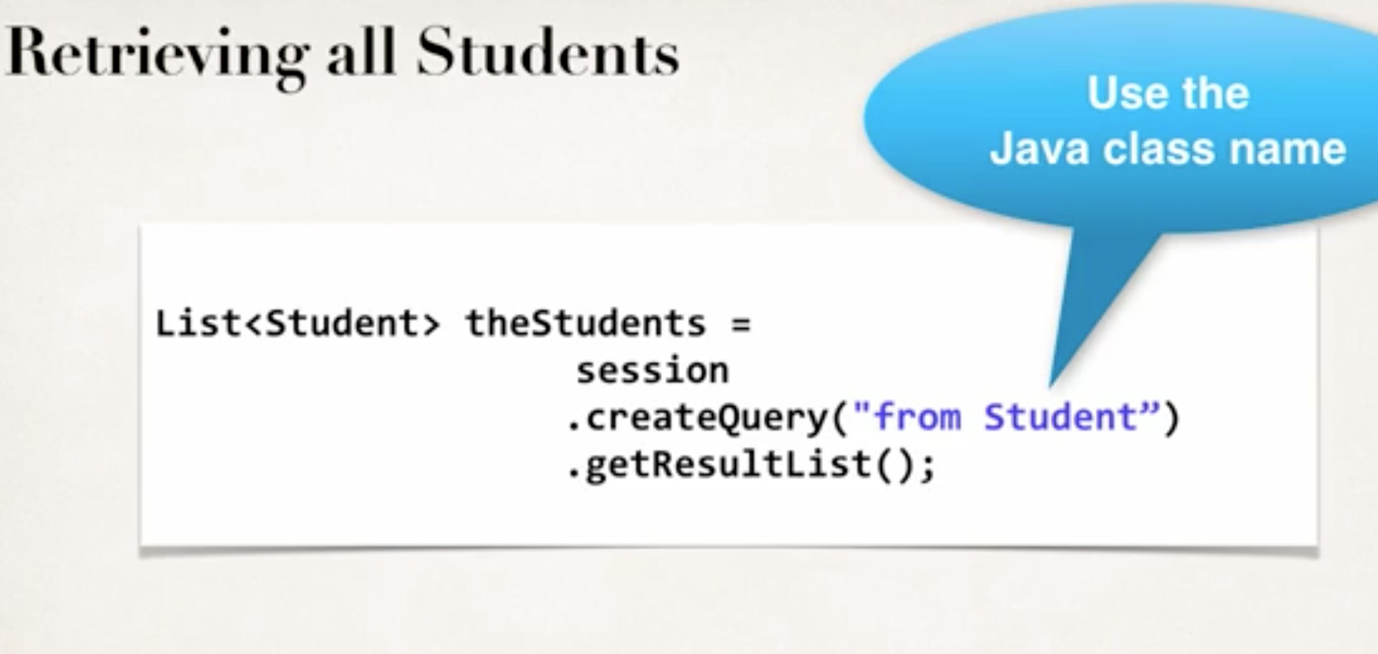

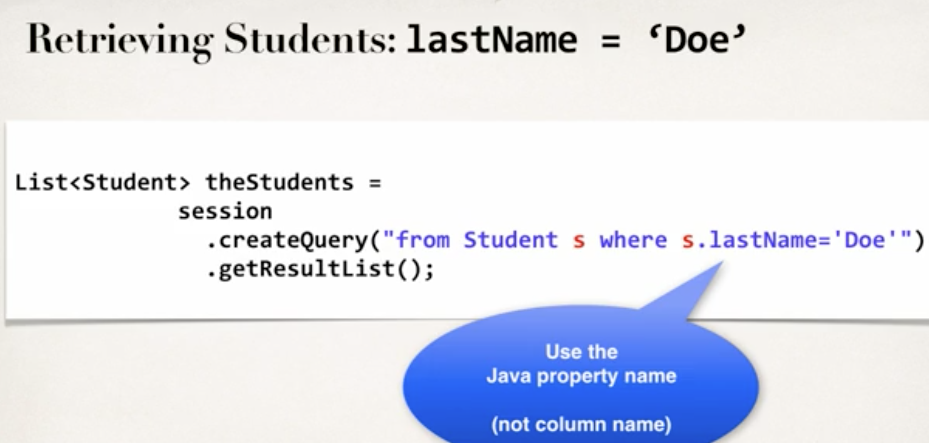

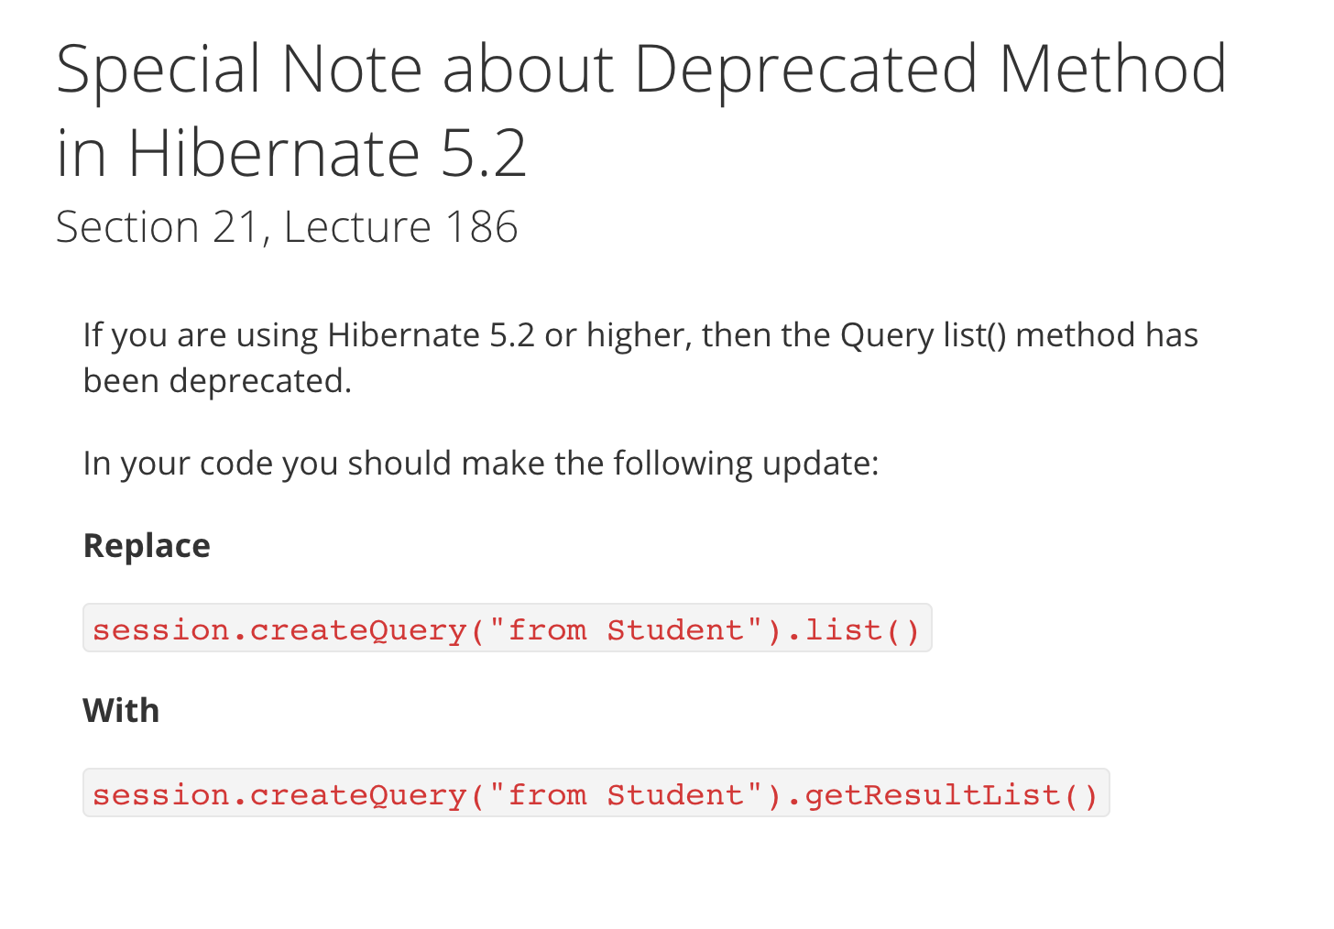

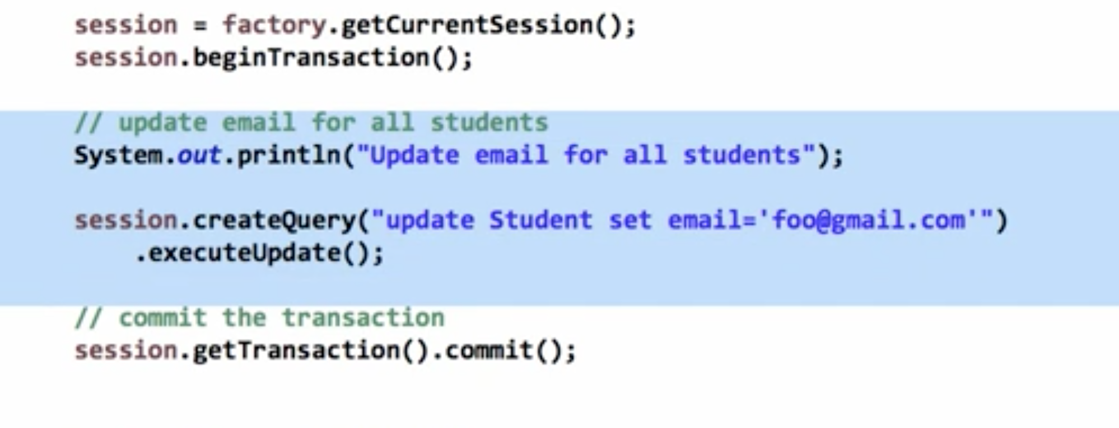

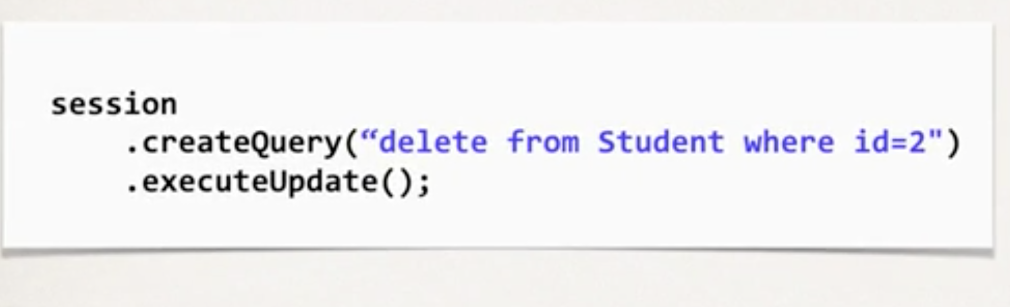

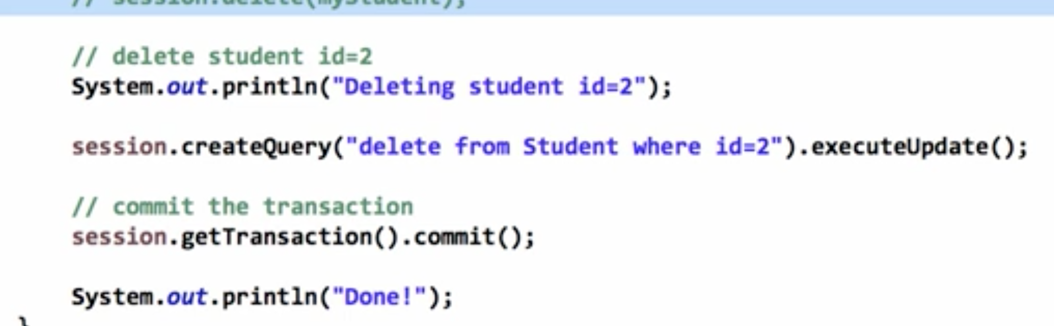

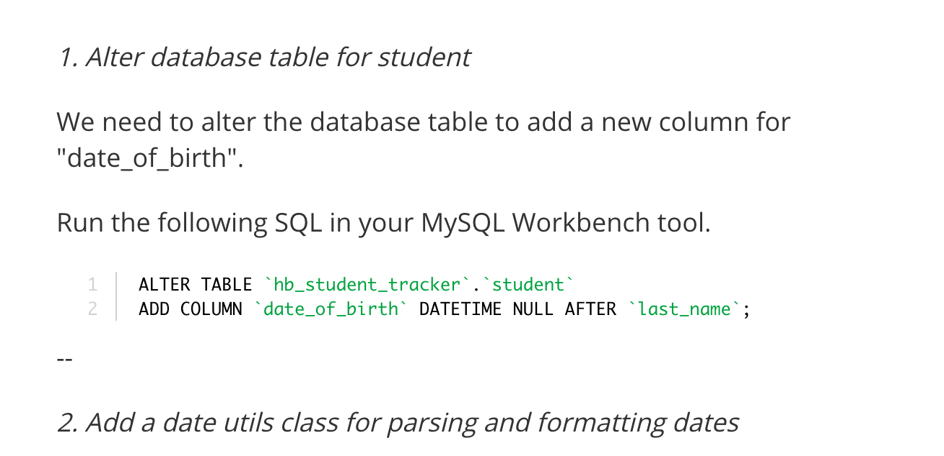

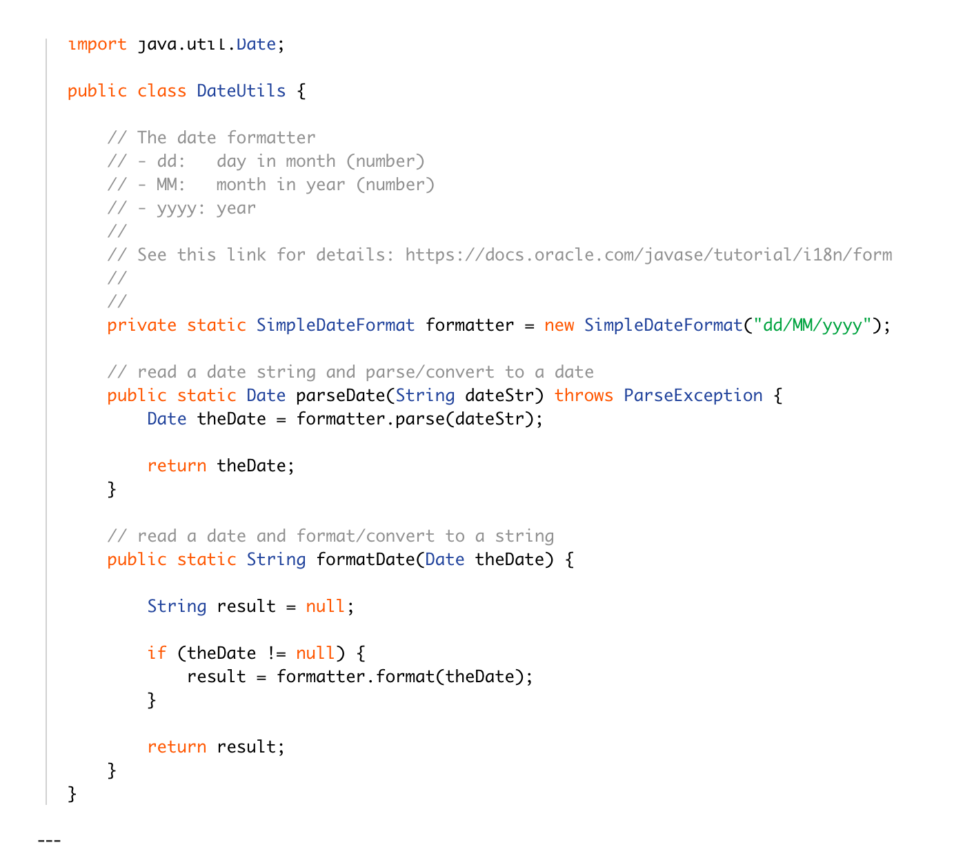

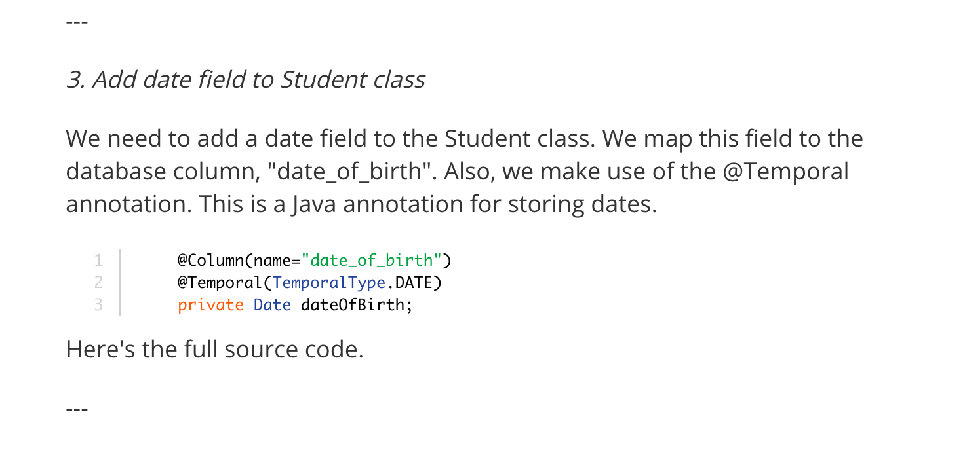

SECTION 22: BUILD A DATABASE WEB APP–I

SECTION 23: BUILD A DATABASE WEB APP–II

SECTION 24: BUILD A DATABASE WEB APP–III

SECTION 25: BUILD A DATABASE WEB APP–IV

SECTION 26: BUILD A DATABASE WEB APP–V

SECTION 27: BUILD A DATABASE WEB APP–VI

SECTION 28: ASPECT-ORIENTED PROGRAMMING (AOP)

SECTION 29: AOP @Before ADVICE TYPE

SECTION 30: AOP POINTCUT EXPRESSIONS, MATCH METHODS AND RETURN TYPES